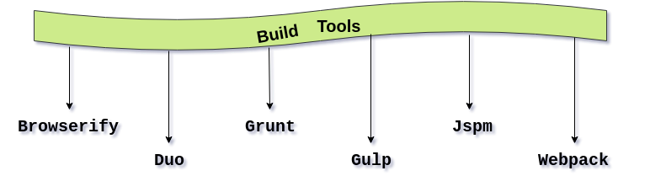

* **Reference**

<https://www.javatpoint.com/typescript-build-tools>

<https://www.javatpoint.com/migrating-from-javascript-to-typescript>